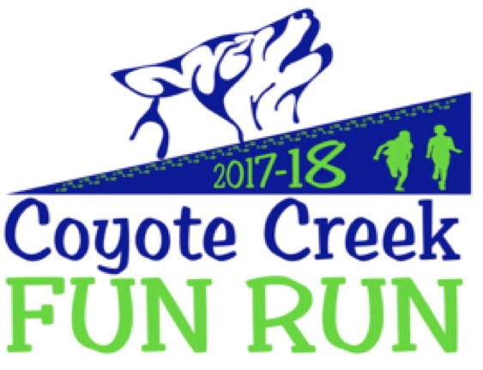  - Mar 28  Coyote Creek’s Fun Run is a fun fitness activity for Transitional Kindergarteners through Fifth Graders. All children will run laps on the Coyote Creek field and aim for their personal best distance. We hope you will join your child for a fun day on the field! Our goal is to create a community-building day for all! The children will also raise money from family and friends, which will go directly back to our school to benefit our students. Targeted programs include Computer Instruction, Para-educators in the classroom, Library, Art and Music. |  | FUN FITNESS ACTIVITY FOR TK – 5th GRADE  LIVE MUSIC  BUBBLES  MUSIC  fun run T-shirt  LIVE MUSIC  post run REFRESHMENTS  fabulous prizes for HITTING FUNDRAISING TARGETS  FUNDS RAISED support school programs: ART, music, COMPUTERs, library and PARAs  pledge online at  www.pledgestar.com/coyotecreek  Waivers & Pledges Due  Mar 21  Final pledges & donations Due Apr 18

Coyote Creek’s 12th Annual Fun Run
Wednesday, March 28th, 2018
Rules

      - Parent Signature is required for student participation in this event whether or not pledges are collected. Please complete attached waiver form and pledge sheets (for offline pledges only) and return to your child’s classroom teacher by Wednesday, March 21, 2018.

      - We have teamed up with PledgeStar to offer you an easy online system to collect pledges. Follow the simple registration steps— It takes just minutes to set up your child’s own fundraising page. Your family and friends can support your child and donate online in a few simple steps. A thank you note from your child will automatically be sent to those who donate online. It's fun, give it a try! Students may start collecting their pledges right away! Register at: http://www.pledgestar.com/coyotecreek

      - To collect offline pledges (e.g., in person), please complete the attached pledge sheet. You must turn in pledge sheets by Wednesday, March 21, 2018. Please note: further pledges can be collected after the event. If you exclusively use the online system to collect pledges, you don’t need to turn in a pledge sheet.

      - Pledge requests should be to family, friends and neighbors only. Please stay away from strangers or going door-to-door, please do not allow your child to sponsor another child and please do not ask Coyote Creek teachers, staff or the Principal to sponsor a child.

      - Each sponsor making a pledge should write their own name, pledge per lap OR flat donation. Pledges may be collected in advance but please do not turn in any money until after the event!

      - On the day of the Fun Run, each class will walk/run during a specified time period on our field. Each participant will be issued a uniquely QR coded sticker which will be scanned each time the student reaches the starting point, thereby keeping track of the number of laps completed. Most students run between 15-25 laps on average.

      - Upon completion of the Fun Run, each student’s lap totals will be tallied up and communicated via the online pledge system (PledgeStar) or noted on your pledge sheet by Wednesday, April 11th. Students may then collect outstanding/additional pledges. Please enter all offline pledges in your pledge sheet and return with the money to the school by Wednesday, April 18, 2018. All money needs to be turned in by that date in order to be eligible to win prizes. For your convenience, a box will be placed in the office and an envelope will be in each classroom for pledge form and money collection.

      - Checks are preferable, made payable to CCLF. Please include the child’s name and teacher’s name in the memo section. If you are turning in cash, please place it in a labeled and sealed envelope.

      - Participants are encouraged to wear hats and sunscreen and good walking/running shoes.

We look forward to all of our participants having a great time! For questions, concerns, or to volunteer contact Jay Balasubramanian at jbalasub@yahoo.com.

Coyote Creek’s 12th Annual Fun Run
Wednesday, March 28th, 2018

PARTICIPATION WAIVER

Dear parents,

Student participation in this event requires a Parent/Guardian Signature. Please sign below & return to your child’s teacher by Wednesday, March 21st.

I allow my son/daughter to participate in the Coyote Creek Fun Run 2017-18.

____________________________________________________________________
(Student’s Name)

_____________________________________________________________________

(Teacher’s name) (Room #)

________________________________________
(Parent/Guardian Signature)

Dear Pledge Sponsor, I am participating in the Coyote Creek Fun Run. All proceeds help fund our school programs. Please sponsor me for an amount per lap (ex: if I run 20 laps at $3/lap, your contribution would be $60 total) OR a flat amount (ex: you could sponsor me a flat amount of $50 regardless of how many laps I complete). I will inform you of my lap total and collect your contribution after the event. Thank you! Pledge Sheets due by March 21st, 2018.

I plan to walk/run _______ laps (most students run between 10-15 laps)
Name of Pledge Sponsor |  | Pledge per Lap  (Minimum $.50 x Total Laps) | OR | Flat Donation  (Minimum $2) | OFFICE USE ONLY  Amount Due
1
2
3
4
5
6
7
8
9
10
11
12
13
14
15
 | Shaded areas for Office Use ONLY!! |  |  | Total of all Pledges:
Please make checks payable to CCLF. All contributions are tax-deductible. Tax ID # 02-0740700

