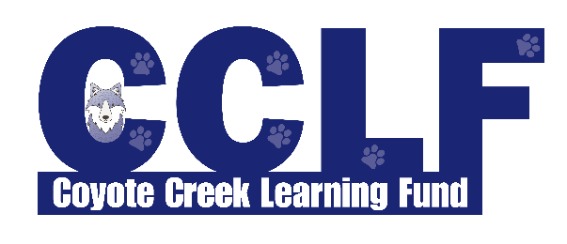
COMMUNITY PARTNERS PROGRAM
2021-2022 SCHOOL YEAR

The mission of the Coyote Creek Learning Fund (CCLF) is to provide financial support to enhance the curriculum at Coyote Creek Elementary School (CKES), primarily in the areas of reading, math, technology, science and art. Our organization depends on donations from community members like you to help support our programs and make a difference in the education of our students.

Our Community Partners Program offers flexible monetary donation levels with differing benefits to show our appreciation for your support, including online marketing These benefits include marketing opportunities at various school events, and advertising on our school and learning fund websites because we know that, as a business owner, name recognition is vital to increasing your customer base (see Page 2 for details). Parents of CKES have told us that businesses that partner with CCLF are often the first businesses they turn to when they need particular services. By partnering with us, you will have an opportunity to reach more than 500 families living in San Ramon.

We look forward to having you as a Community Partner in enhancing the educational experiences and opportunities for all students at Coyote Creek Elementary School! Please complete the information below and mail it to:

Coyote Creek Learning Fund
Attn: Shail Rajan, President
8700 North Gale Ridge Road
San Ramon, CA 94582

If you have any questions, feel free to email us at coyotecreeklearningfund@gmail.com.

To learn more, visit us online at https://ckes-srvusd-ca.schoolloop.com/cclf
Like us on Facebook: https://www.facebook.com/CoyoteCreekLearningFund/

To become a Community Partner, please complete the information below.

Company Name: ____________________________________________________________________

Address: ___________________________________________________________________________

Contact Name & Title: _______________________________________________________________

Phone: _________________________________ Email: ____________________________________

Partner Level - (Circle One):
Platinum Coyote or Gold Coyote or Other (we will contact you to go over options)

If you are enclosing a payment: Amount ________________ Check Number ________________
Please make checks payable to Coyote Creek Learning Fund.

Signature: ____________________________________ Date: ________________________________

This year CCLF will welcome businesses to join us at the Platinum and Gold partner levels. These partners will be accepted on a first come, first served basis. If you wish to discuss other sponsorship opportunities and benefit levels, please select “Other” as your Partner Level on page 1.

Note: Logos and other marketing material must be received by the date requested in order to be included.

Benefits | Platinum Coyote Partner  $2,000 Donation | Gold Coyote Partner  $1,000 Donation
Your company logo and a link to your business website on the CCLF webpage
https://ckes-srvusd-ca.schoolloop.com/cclf

Recognition of your company in CCLF newsletters and marketing materials distributed to all CKES families
A “like” and “thank you” of your business social media accounts across CCLF social media accounts.

Recognition of your company at our annual Spring Auction Fundraiser* | Full Page Ad | Half Page Ad
2 tickets to our Spring Auction Fundraiser (date TBD)*

In order to ensure a consistent approach, the CCLF Board determines final approval of all partners and reserves the right to reject any partner at any time for any reason. We will refuse any partner that we believe is incompatible with our mission or inappropriate for our students. In such an event, CCLF will provide prompt notice to the partner. Acceptance of partnership does not imply endorsement of any products or services by CCLF. In cases where CCLF links to the website of the partner, it must be understood that CCLF does not regulate the content of the partner’s website and assumes no responsibility or liability for any claims or endorsements made on, or linked to, the partner’s website. The Community Partners Program period is from August 1, 2019 to May 29, 2020. CCLF reserves the right to amend this policy without public notification.
*Subject to change in the event that the Spring Auction Fundraiser event is cancelled.

